Keep your Branch informed

Forward this email to your Branch Executives, Committee Members and other members to keep them up-to-date on important updates and information.
All Branch emails are also available on the Member Services Website

In this edition – July 2022

> | Marking National Indigenous History Month
> | The Legion Nationals are back!
> | New membership handout

> | Sponsor a flag at Juno Beach
> | Using the Poppy trademark: Edible products
> | Messages from our partners

Honouring Indigenous History Month
The Legion helped mark National Indigenous History Month by sharing how Indigenous traditions exist within the organization today, how they are shaping the future, and how a historic law affected Aboriginal comrades and the Legion.
“…we recognize that complete societal and organizational healing and change can take a long time and there is a lot of work to do,” says Legion Dominion President Bruce Julian. “I can assure you that our Indigenous comrades and their customs form an integral part of our organization’s fabric today, and we are constantly looking at what we can do better to recognize their history and support a positive future.”
Read more ‣
The Legion Nationals are back!
The 44th Royal Canadian Legion National Youth Track and Field Championships will be held from August 5–7, 2022 in Sherbrooke, Quebec.
This one-of-a-kind event for youth aged 12–17 is an important aspect of The Royal Canadian Legion’s commitment to the development of Canada’s youth.
Support Canada’s young athletes and spread the word within your communities!
Learn more about Legion Nationals ‣ | Download athlete flyer ‣
New! Bilingual Join Brochure
The Legion’s new Join brochure can help you recruit new members to your Branch. The bilingual brochure is available through Legion Supply (product number 800307) or by download here.
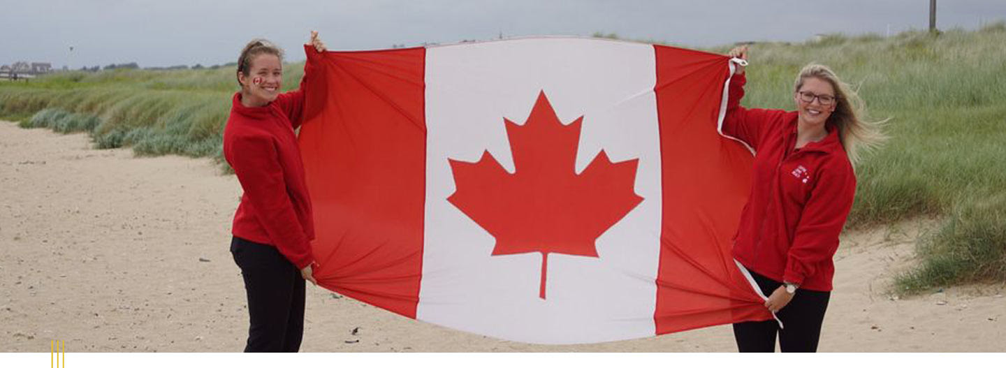
Juno Beach Centre Flag Sponsorship Program
You can own a Canadian flag that flew above Canada’s D-Day landing beach while helping support the Juno Beach Centre!
For a minimum of $500, you can sponsor a flag that will fly at the Juno Beach Centre in France, to be returned to you with a certificate of authenticity and the dates when it was flown. What a beautiful way to honour those who landed on the beach 78 years ago.
Learn more ‣
Poppy Trademark – Cannot be used in food products
Did you know… the Remembrance Poppy cannot be used on edible products. Items such as cookies or cakes designed with a Poppy to honour Veterans are not an approved use, as the sacred Poppy should never be consumed.
See the attached educational flyer for Branches that highlights important information about the Poppy trademark, and requirements for use.
Download the flyer ‣
Please direct public inquiries to: www.legion.ca/poppy-trademark.
Branch Membership Administration
Resources and tips to support your Membership Chair

+ 2023 MEMBERSHIP RENEWAL STICKERS
2023 stickers will be delivered to Branches the last week of August for all members who have renewed for 2022 by the end of July 2022. Please ensure your 2022 renewals are processed before the end of July.
+ FALL MEMBERSHIP RENEWAL CAMPAIGN
As we prepare for the busiest time of the year for membership renewals, we encourage you to update, collect and upload member email addresses and phone numbers within the membership website. With this information, we can cost-effectively remind members to renew on your behalf via one of these renewal options:
- at your local Branch
- by phone – by contacting member services
- online – 34% of all Legion members renewed online during 2021 and this number continues to grow during 2022!
This approach can help save local Branches and membership chairs time and money!
Veteran Family Welcome Program eligibility has expanded
Parents, guardians, spouses and adult children of serving, retired or passed CAF and RCMP members who have not yet joined the Legion can now receive a first free year of membership at the Legion.
Encourage Veterans and eligible family who have not yet joined to register today.
Promotional Poster ‣ | Veteran application form ‣
Family application form ‣ | Online application ‣

+ Legion membership is growing!
Here’s how you can continue to help with this growth:
- Reach out and welcome new members who join your branch within the first 30 days
- Collect and share member emails and phone numbers within the membership system
- Ensure you are processing memberships at least monthly
- Promote the free year Veterans Welcome and Veterans Family Welcome Programs to non-members
- Promote our free MemberPerks® program to all members
- Feel free to reach out to Member Services with any questions – we are here to help all and especially new Membership Chairs!

Get access to Marketing and PR resources

Marketing Resources

Updated Branch Brand Manual
The Official Colours Chart for Legion Graphics in the Brand Manual has been updated. As technical color processes continue to improve, the Pantone Matching System Guides have been updated to offer more CMYK colours. The updated colour codes allows us to reproduce our brand colours more accurately within the CMYK process printing. Download and update your copy.

PR Tip of the Month
Remember the Legion is apolitical
When approached by media or others to comment on political matters or participate in petitions, remind them the Legion is apolitical. We work behind the scenes and respectfully advocate with all governments, through all PR channels, for changes to benefit Veterans and their families.
Have questions or need advice? Contact your Command Public Relations Officer or Nujma Bond, Dominion Command Communications at nbond@legion.ca

Your Legion calendar
August 19 marks the 80th anniversary of the Dieppe Raid, one of the most devastating chapters in Canadian military history.
Learn about the Dieppe Raid and other important dates your Branch can commemorate or promote.
Download the 2022 calendar ‣

MemberPerks®: Exclusive offers and preferred pricing through Venngo
MemberPerks® is more than a member benefit package. It’s also a tool Branches can use to promote membership. Plus, you can partner with local businesses in your community to offer exclusive discounts for your members.
Learn more ‣

Partner promotions
The following is brought to you by our partners, highlighting special offers and other information.

Pocketpills: Our newest Member Benefits Partner
Pocketpills brings the pharmacy to you! Through their easy-to-use app and website, you can fill prescriptions, order vitamins, and consult with pharmacists—all from the comfort of home. Help us get the word out about our new online pharmacy partner! Sign up for Pocketpills today by calling 1-855-950-7225 and mention that you are a Legion member for exclusive benefits.
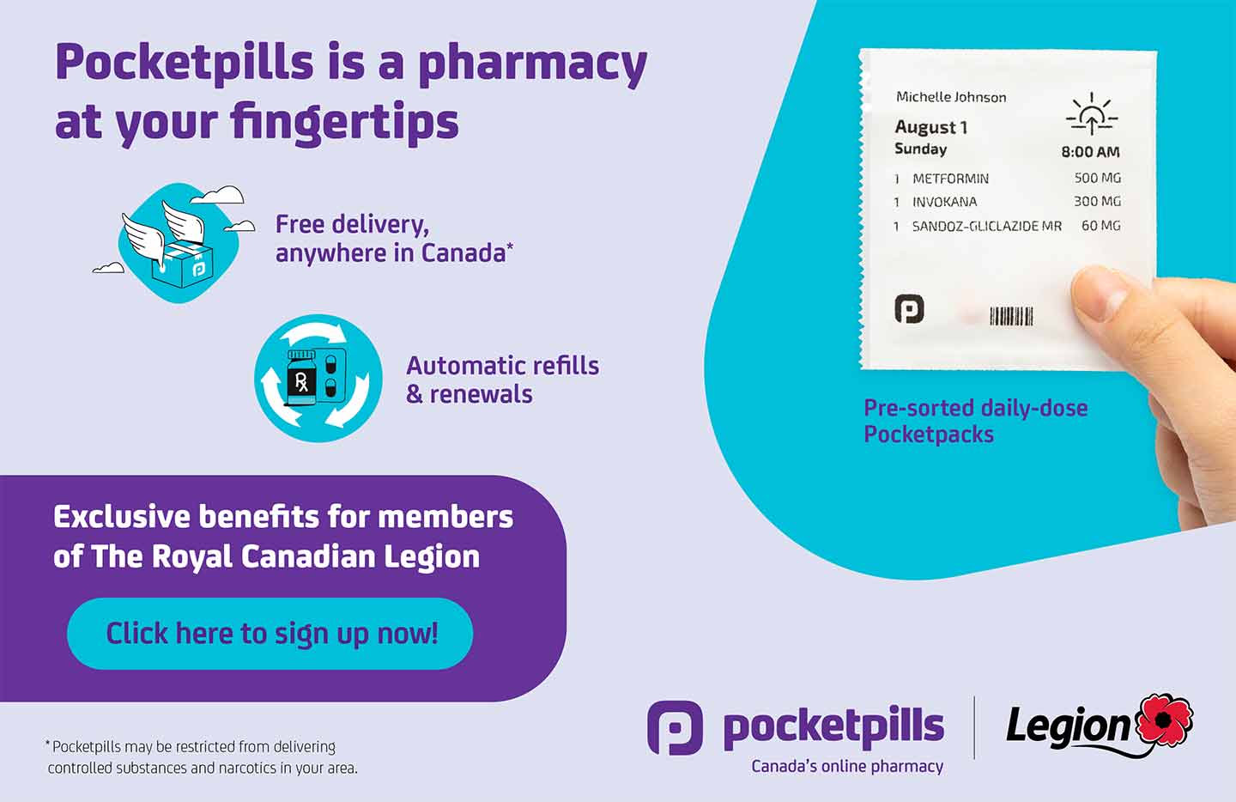
The Professional Institute of the Public Service of Canada’s supports Legion Nationals
The Royal Canadian Legion is extremely grateful for The Professional Institute of the Public Service of Canada’s support of the 2022 Legion National Youth Track and Field Championships and their commitment to Canada’s youth!
An evening with Margaret MacMillan
The Legion National Foundation invites you to a special event featuring award-winning author Margaret MacMillan as she discusses her writing, her experiences, and the history of war.
Monday, September 12, 7:00–8:30 p.m. EST
In-person (Toronto) and virtual event. Registration is complimentary.
Visit LNFCanada.ca/upcoming-events/ to register.
Special offer from Legion Magazine
If you have any questions, please contact Member Services and we will be pleased to assist. 1-855-330-3344 or membership@legion.ca
Office Hours: Monday - Friday, 8:30 a.m. - 4:00 p.m. EST
Working together to serve Canada’s Veterans.

